Data Structures (ETCCDS202)
Unit–1 Assignment: Foundations & Algorithmic Analysis
Course Details
Name of the School:SOET (School of Engineering & Technology )
Program : CSE Robotics and AI
Semester :2
Batch:2025-2029
Student Name:Ajitesh Singh Gusain

Task 3: Dynamic Array Simulation
3.1. Dynamic Array Concept
A DynamicArray acts as a wrapper around a static array that automatically resizes when it reaches its current capacity limit. By implementing methods like append(x), pop(), get(i), and set(i, x), the structure provides a flexible list-like interface. When the array is full during an append operation, it typically doubles its capacity to accommodate new elements.

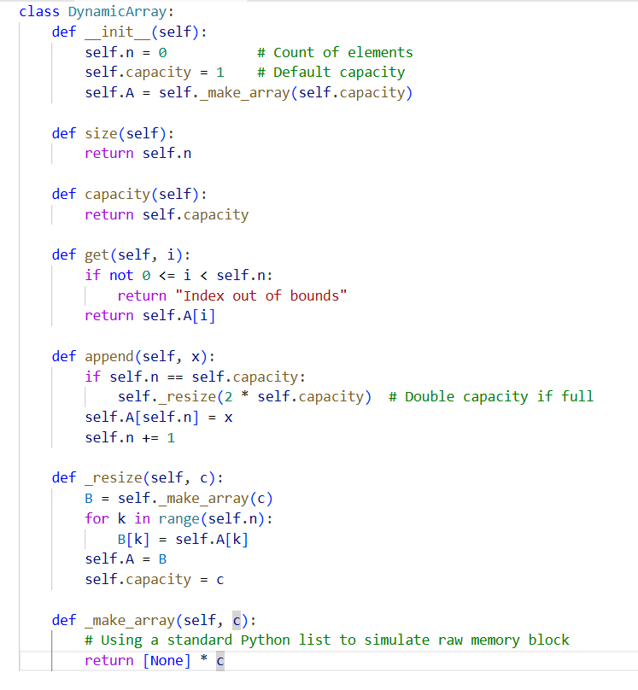

3.2. Amortized Analysis
While a single append(x) operation may take O(n) time when a resize occurs (due to copying all elements to a new memory block), most insertions occur in O(1) time because there is existing space. We describe this as amortized O(1) because the cost of the rare, "expensive" resize operations is distributed over the many "cheap" operations, resulting in an efficient average-case performance.
3.3. Experiment Pattern (Size vs. Capacity)
When performing an experiment by appending elements 1 through N, the following pattern is observed:
- The current size increases by 1 with every append operation.
- The current capacity remains constant until the size exceeds the capacity, at which point the capacity doubles.
- This observation confirms the design trade-off where memory is pre-allocated (unused capacity) to ensure that insertion operations remain fast.
- 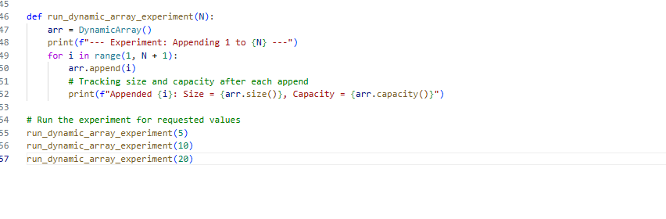
- 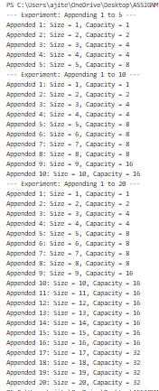
Task 4: Linked Lists (Singly + Doubly + Circular Understanding)
Task 4.1
Search Choice: I chose to have the search(x) method return a boolean (True or False). This is an efficient way to check for the existence of an element without needing to track index positions, which are not native to standard linked lists.
Handling Graceful Deletion: In delete_by_value(x), the code checks if the list is empty or if the value does not exist in the list. If the value is not found after traversing, it prints a message instead of causing an error, fulfilling the "handle gracefully" requirement.

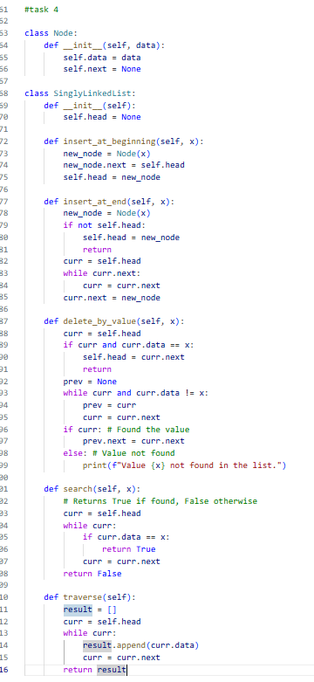

Task 4.2
Node Structure: Unlike a Singly Linked List node, this node contains an additional prev pointer. This allows for bidirectional traversal, meaning you can move both forward and backward through the list.
Insertion Logic (insert_after_node): To insert a new node after a specific "key," the algorithm first searches for that key. Once found, it updates four pointers: the next and prev pointers of the new node, the next pointer of the current node, and the prev pointer of the following node.
Deletion Logic (delete_at_position): This method removes a node based on its 0-based index. If the node is in the middle, its neighbors are linked directly to each other, effectively bypassing the target node. If the first node (position 0) is deleted, the head pointer is updated to the second node.
Edge Case Handling: The implementation gracefully handles cases where the specified "key" is not found or the "position" provided is out of the list's current range by printing a descriptive message instead of crashing.

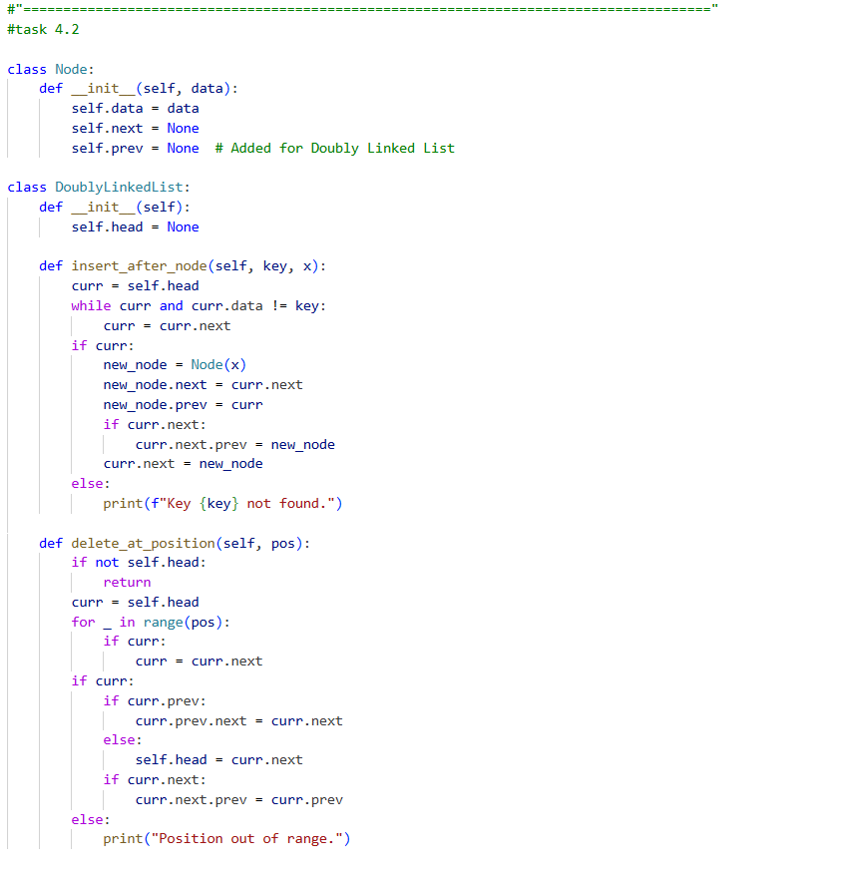
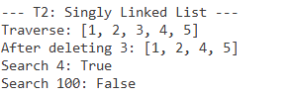

Task 4.3: Circular List Concept
- Definition: A Circular Linked List is a variation where the last node does not point to None, but instead points back to the head node, creating a continuous loop.
- Real-World Use Case: This structure is highly useful for round-robin scheduling in operating systems, where tasks are given time slices in a repeating, cyclic order. Another common example is a playlist loop in a media player, where after the last song, the system automatically returns to the first song.

Head

|
+---+---+ +---+---+ +---+---+
| A | ●------> | B | ●------> | C | ●---|
+---+---+ +---+---+ +---+---+ |
^ |

|_______________________________________|
(Last node points back to Head)

5.1. Stack (LIFO) Implementation
For a Stack, it is most efficient to use the head of the linked list as the "top". This allows both push and pop operations to happen in O(1) time because we do not need to traverse to the end of the list.
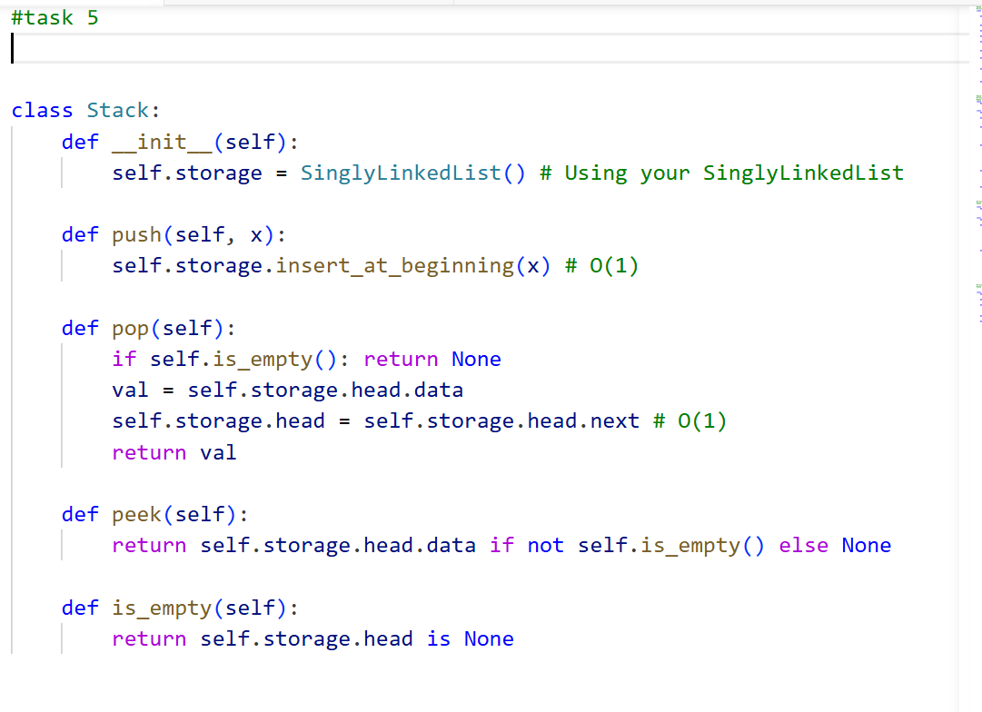

5.2. Queue (FIFO) Implementation
For a Queue, we must maintain both a head and a tail pointer. enqueue adds to the tail and dequeue removes from the head. Both remain O(1) with these pointers.
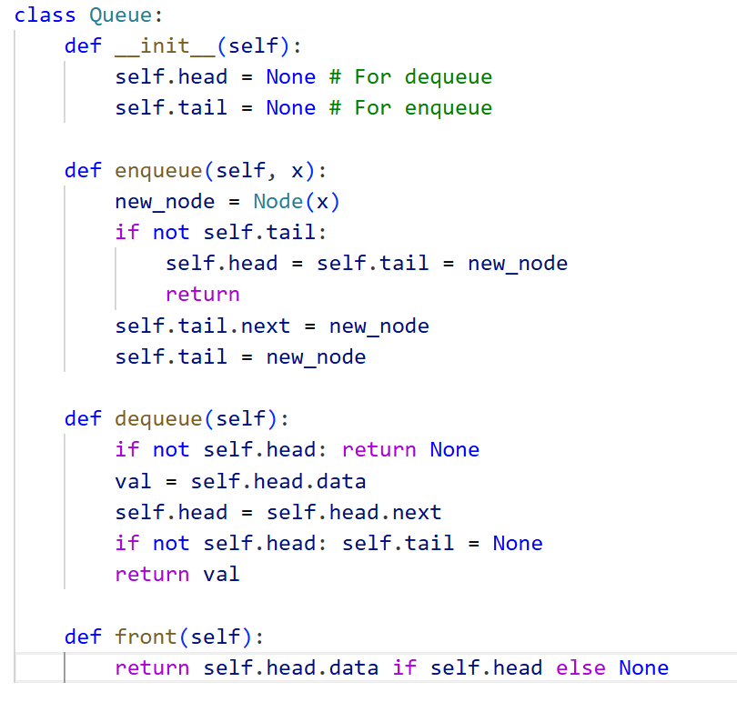

5.3. Complexity Table

Operation | Array-based | Linked List-based | Reason
Push/Pop | $O(1)$ | $O(1)$ | Both access the same end directly.
Enqueue | $O(1)$ | $O(1)$ | LL uses a tail pointer for instant access.
Dequeue | $O(n)$ | $O(1)$ | Array requires shifting; LL just moves head.

Task 6: Parentheses Checker
- When to push: When you encounter an opening bracket: (, [, {.
- When to pop: When you encounter a closing bracket: ), ], }. Check if the popped element matches the current closing bracket (e.g., ( matches )).
- Invalid immediately: If you encounter a closing bracket but the stack is empty, OR if the closing bracket does not match the type of the last popped opening bracket.
- Why empty stack = balanced: If the stack is empty after processing the entire string, it means every opening bracket was correctly closed in the proper nested order.
- 